The artists listed below will be setting up at the Etchberger Memorial Park in Hamburg.
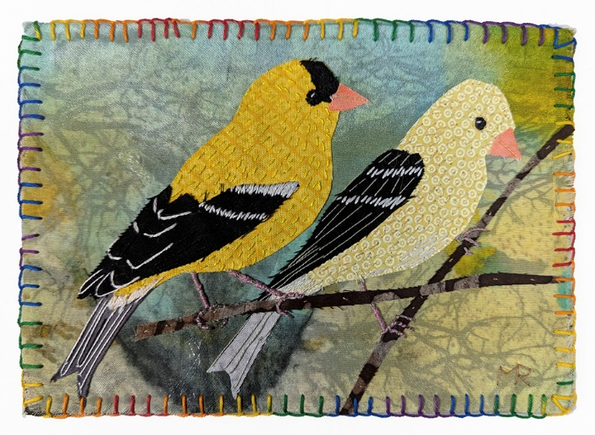
Artist’s Name: Martha Ressler
Studio Name: Ressler Art Studio
Lives in: Hamburg
Artist’s Email: meressler@gmail.com
Phone #: 412-445-7359
Artist’s website: martharessler.com
Is artist doing a demonstration: No
Short description of artwork: Studio art quilts and fiber collage

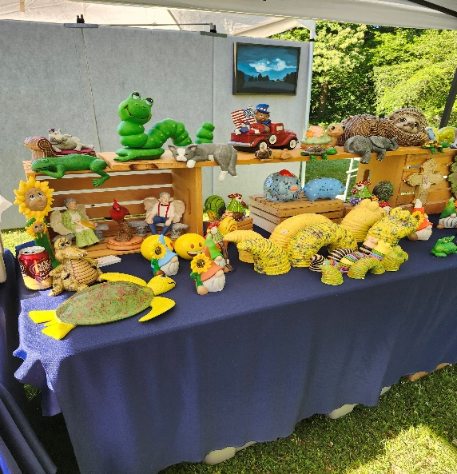
Artist’s Name: Susan Boyer
Studio Name: Susan’s Ceramics
Artist’s Email: boyerse123@gmail.com
Phone #: 610-898-4309
Artist’s website: N/A
Is artist doing a demonstration: No
What is the demonstration: N/A
Short description of artwork: Ceramics-for home and garden decorating

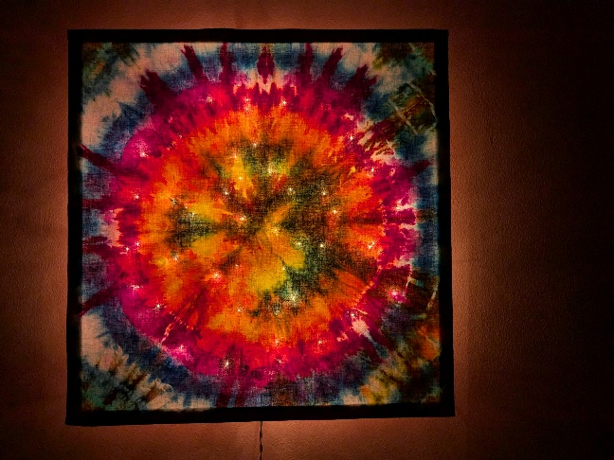
Artist’s Name: Linnae Goda
Studio Name: Linnae’s Lumens LLC
Lives in: Hamburg
Artist’s Email: Linnaes.Lumens@gmail.com
Phone #: 610-334-2299
Artist’s website: Facebook and Instagram
Is artist doing a demonstration: Yes
What is the demonstration: Tie Dye
Short description of artwork: Ice dyeing of cotton cloth which is used to create luminaries, light boxes, wall hangings and other items for home décor and personal use.
In addition to these three artists, Schuylkill River Greenways NHA, will be setting up an informational table to promote the trails along Etchberger Park and surrounding areas.

After visiting Hamburg Area Arts Alliance members at the Etchberger Park in Hamburg, be sure to travel a few short blocks to the Art & Craft Gallery of Hamburg located at 320 State Street in downtown Hamburg. There you will find handmade creations and artwork from over 30 local artists – all for sale at affordable prices.

