Hawk Mountain Sanctuary

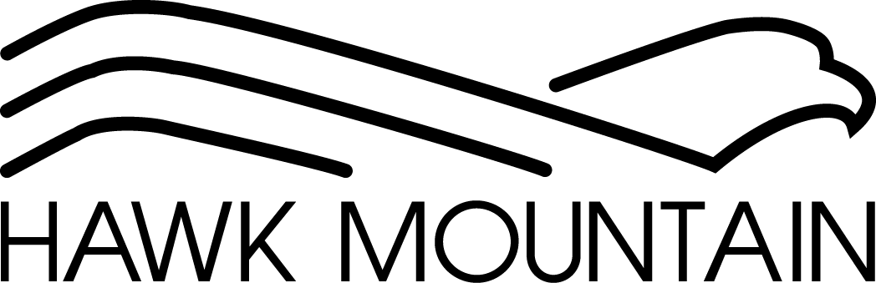
1700 Hawk Mountain Road Kempton, PA 19529
Phone: 610-756-6961
Fax: 610-756-4468 ___________________________________________________________________________________

Waiver and Release of Liability, Assumption of Risk,
and Indemnity Agreement

Program Activity: Summer Camp (“Program Activity”)
In consideration of being allowed to participate in the aforementioned Program Activity, I, on behalf of myself, my participating child, and any personal representatives, heirs, and next of kin, acknowledge, understand, and willingly agree to the following:
- I hereby authorize and give full consent for my minor child to participate in the Program Activity offered by Hawk Mountain Sanctuary, which also involves programming offered in cooperation with organizations, agencies, entities, and partnerships (“Third-Party Entities”) associated with the Hawk Mountain Sanctuary as part of the Program Activity.
- I acknowledge that the requirements and expectations of the Program Activity have been fully explained to me and my minor child, and that I am fully aware of the obligations regarding myself and minor child under this Program Activity. I acknowledge, agree, and represent that I have inspected and carefully considered the premises, equipment, facilities, and preventative measures related to the Program Activity, and I find and accept same as being safe and reasonably suited for the use or participation by my child in the Program Activity.
- I also am aware of the highly contagious nature of the novel Coronavirus/COVID-19 (the “Disease”) and the risk that my child, myself, and other persons may be exposed to or contract the Disease by my child’s participation in the Program Activity. Further, I am aware that attending the Program Activity could increase my child’s and my risk of contracting the Disease. I also understand and acknowledge that such exposure or infection may result in illness, personal injury, permanent disability, death, or property damages to my child, myself, or other persons. I acknowledge that this risk may result or be compounded by the actions, omissions, or negligence of my child or others, including but not limited to, Hawk Mountain Sanctuary, Program Activity employees, volunteers, Third-Party Entities associated with the Hawk Mountain Sanctuary as part of the Program Activity, and Program Activity participants and their families. Notwithstanding the risks associated with the Disease, I acknowledge that I am voluntarily choosing to allow my child to participate in the Program Activity.

- I understand that while the Hawk Mountain Sanctuary has implemented preventative measures to reduce the spread of the Disease, Hawk Mountain Sanctuary cannot guarantee that my child will not become infected with the Disease because of participating in the Program Activity. I understand that no list of restrictions, guidelines, or practices will remove all of the risk of exposure to the Disease while my child participates in the Program Activity.

- I, for myself, and on behalf of my child, and our assigns, heirs, successors or agents, hereby agree to accept and assume any and all risks associated with my child’s participation in the Program Activity and accept sole responsibility for any injury to my child or myself, including but not limited, to personal injury, illness, disability, death, property damage, damage, loss, claim, liability, or expense of any kind (including attorney fees), that I or my child may suffer arising out of or in connection with my child’s participation in the Program Activity (including exposure to or infection by the Disease), whether caused by the negligence of the Hawk Mountain Sanctuary, Program Activity employees, volunteers, Third-Party Entities associated with the Hawk Mountain Sanctuary as part of the Program Activity, or other Program Activity participants and their families.

- I, for myself, and on behalf of my child, and our assigns, heirs, successors or agents, hereby expressly waive and release any and all claims, now known or hereafter known, against the Hawk Mountain Sanctuary, and its parents, officers, directors, employees, agents, affiliates, volunteers, representatives, successors and assigns (collectively, “Releasees”) on account of personal injury, illness, disability, death, property damage, damage, loss, claim, liability, or expense of any kind (including attorney fees), that I or my child may suffer arising out of or in connection with my child or myself may suffer arising out of or in connection with my child’s participation in the Program Activity (including exposure to or infection by the Disease), whether caused by the negligence of the Hawk Mountain Sanctuary, Program Activity employees, volunteers, Third-Party Entities associated with the Hawk Mountain Sanctuary as part of the Program Activity, or other Program Activity participants and their families or otherwise. I covenant not to make or bring any such claim against the Hawk Mountain Sanctuary and all other Releasees, and forever release and discharge Hawk Mountain Sanctuary and all other Releasees from liability under such claims.

- I, for myself, and on behalf of my child, and our assigns, heirs, successors or agents, hereby agree to indemnify, defend, and hold harmless Hawk Mountain Sanctuary and all Releasees from and against any and all costs, expenses, damages, claims, lawsuits, judgments, losses, and/or liabilities of whatever kind (including attorney fees) arising from any illness, personal injury, permanent disability, death, or property damages to my child or myself as a result of my child’s participation in the Program Activity (including exposure to or infection by the Disease), whether caused by the negligence of Hawk Mountain Sanctuary, Program Activity employees, volunteers, Third-Party Entities associated with the Hawk Mountain Sanctuary as part of the Program Activity, or other Program Activity participants and their families or otherwise.

- If any portion of this agreement is held invalid, it is agreed that the balance shall continue in full legal force and effect.

- I represent and warrant that I am the parent or guardian of the child whose name appears below and that I have, as of the date hereof, taken all necessary actions to authorize the execution of this agreement and have the full power, authority, and legal right to execute, deliver, and perform the respective obligations under this agreement.

I HAVE CAREFULLY READ AND VOLUNTARILY SIGN THIS WAIVER AND RELEASE OF LIABILITY, ASSUMPTION OF RISK, AND INDEMNITY AGREEMENT AND FURTHER AGREE THAT NO ORAL REPRESENTATIONS, STATEMENTS, OR INDUCEMENT APART FROM THE FOREGOING WRITTEN AGREEMENT HAVE BEEN MADE. I AM AWARE THAT BY AGREEING TO THIS AGREEMENT, I AM GIVING UP VALUABLE LEGAL RIGHTS AS STATED HEREIN. I ALSO UNDERSTAND THAT THIS AGREEMENT IS MADE ON BEHALF OF MY MINOR CHILD AND/OR LEGAL WARDS, AND I REPRESENT AND WARRANT THAT I HAVE FULL AUTHORITY TO SIGN THIS AGREEMENT ON BEHALF OF SUCH MINOR(S).

Signature of Parent/Guardian: _________________________ Date:___/___/___
Printed name of Parent/Guardian: ________________________
Phone number of Parent/Guardian: _______________________
Printed name of Minor Participant(s): ___________________________
Signature of Adult Participant: _________________________ Date:___/___/___

